PRE REQUISITES:

IBM CLOUD SERVICE:

SUCESSFULLY CREATED IBM CLOUD SERVICE

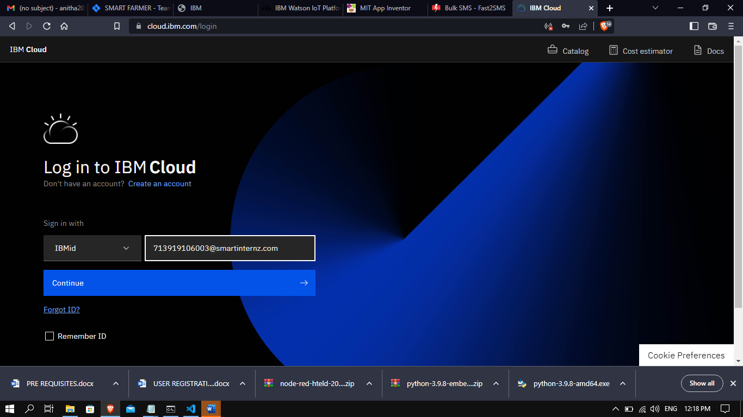

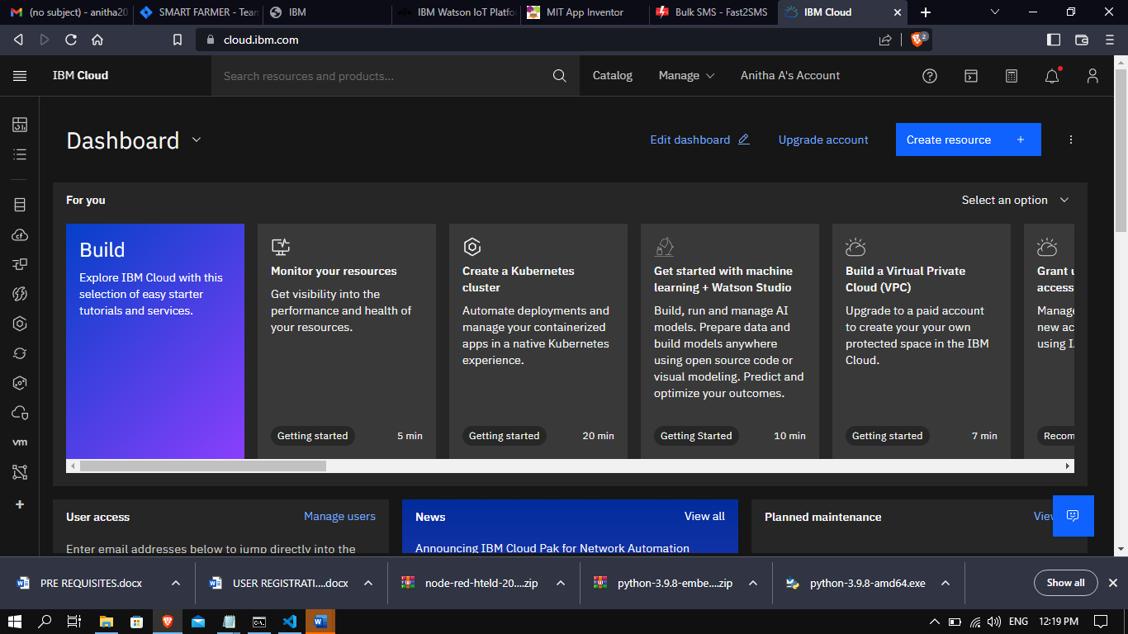

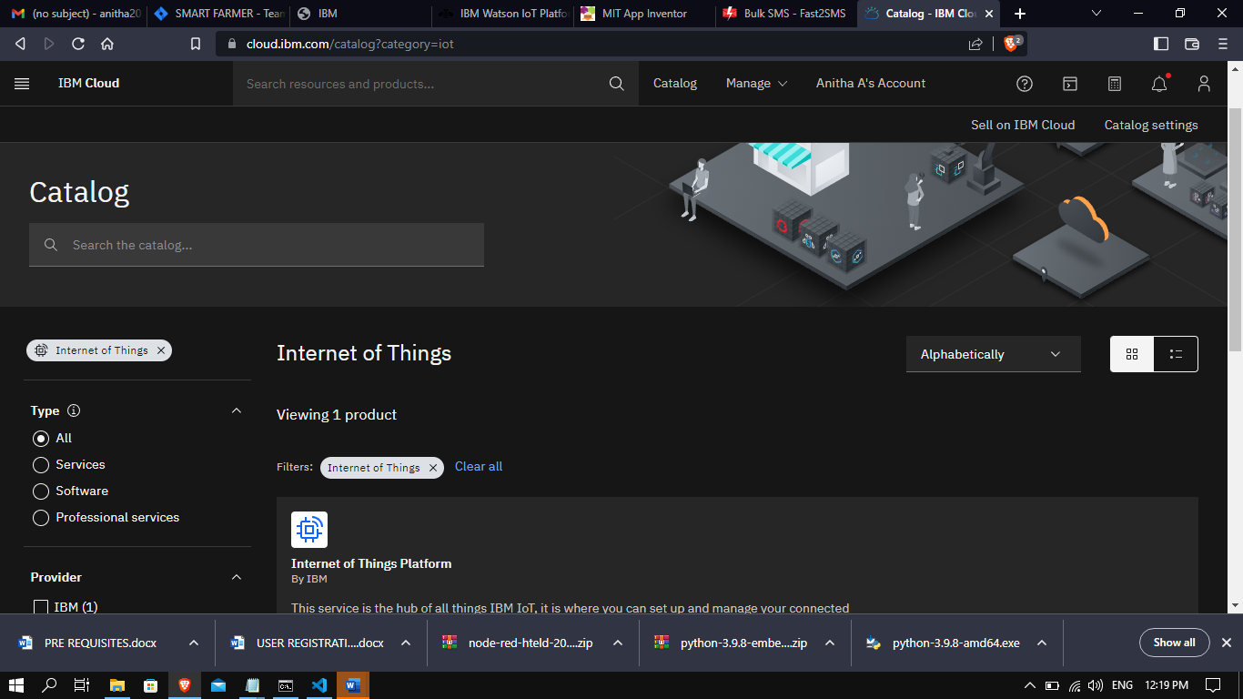

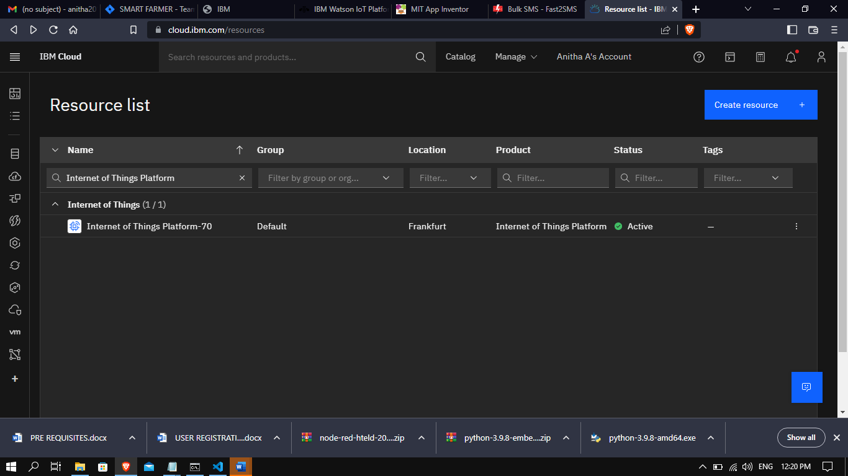

MIT APP INVENTOR

SUCESSFULLY CREATED MIT APP INVENTOR:

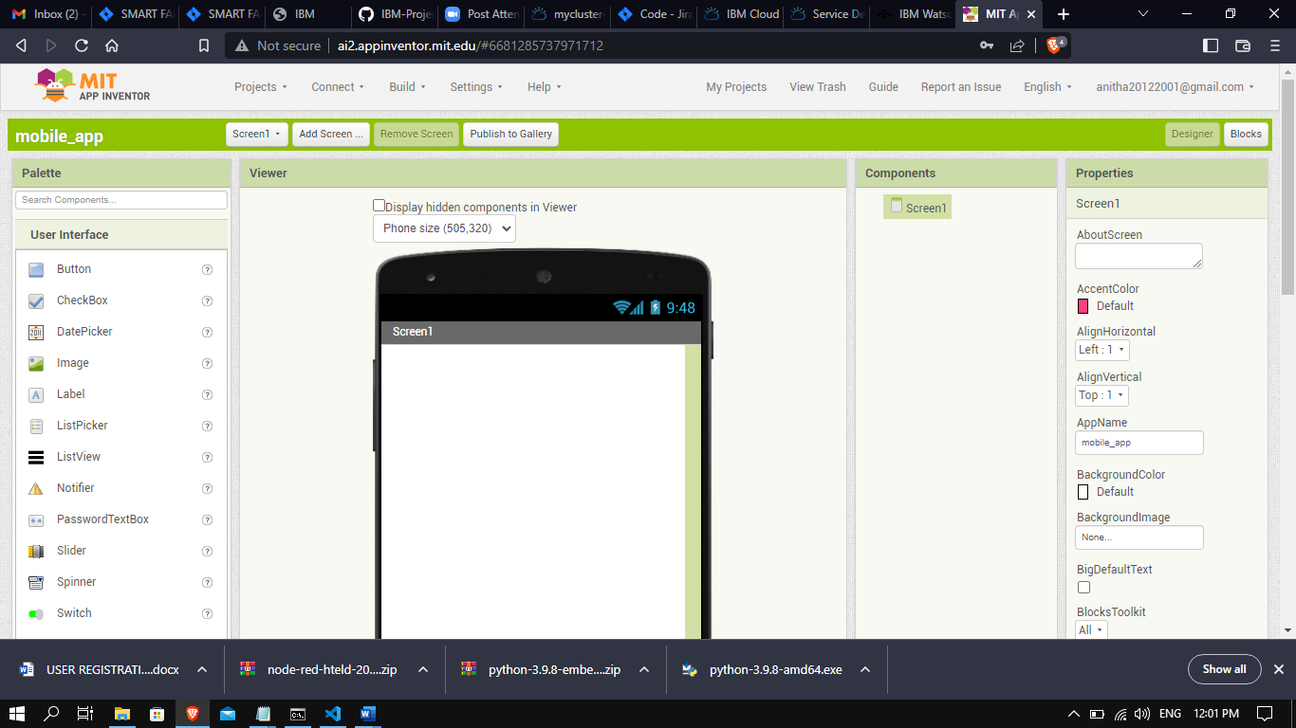

SOFTWARE

REQUIRED SOFTWARE PYTHON 3.9.8 IS INSTALLED:

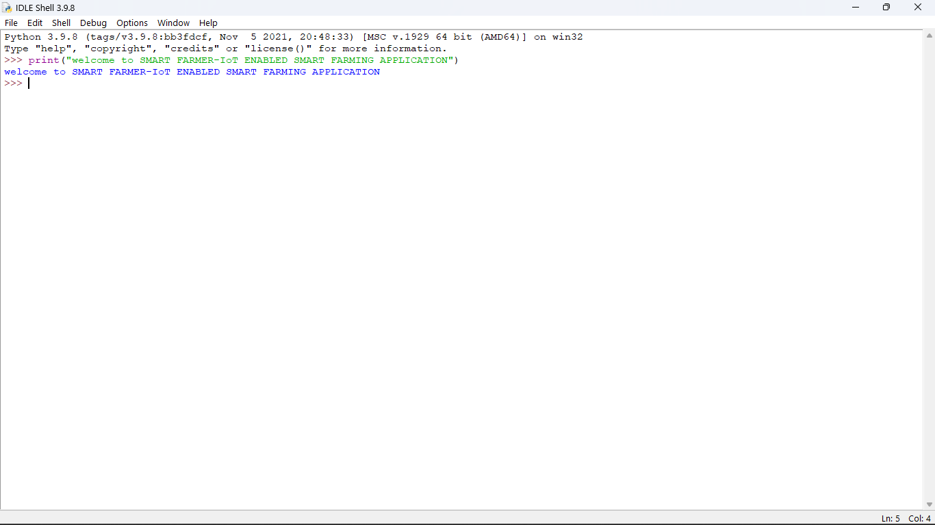

ACCOUNT IN FAST2SMS DASHBOARD:

SUCCESSFULLY CREATED FAST2SMS DASHBOARD:

